TRANSPORTATION

DEPARTMENT
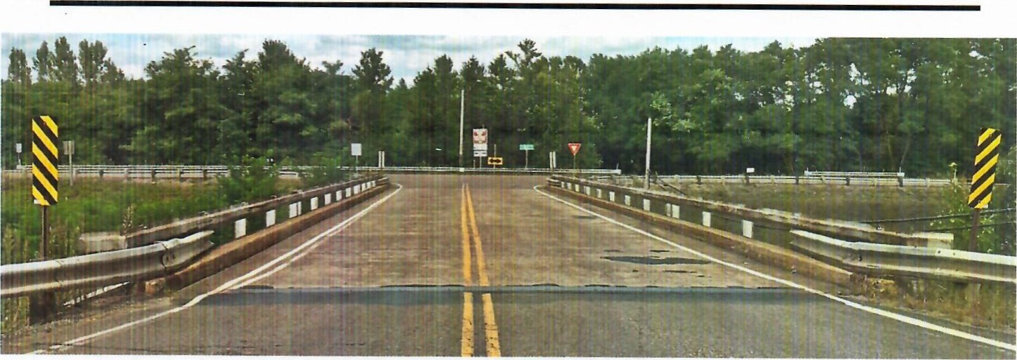
The City of Madisonville Public Works Department is also responsible for maintaining 162 miles of streets inside the city limits of Madisonville. The Public Works Department provides the following services related to the following issues.

MAINTENANCE | • Right of ways
& DRAINAGE | • Storm Sewers
CONCRETE | • Sidewalks
SERVICES | - Curbs & Cutters  - City Owned Parking Lots
PAVING | Each year the city receives "municipal aid" money to resurface an average of 5 miles of street which is contracted out to paving companies.
- Short Sections of the Street
- Using Asphalt to Fill Pot Holes
- Maintenance of Utility Cuts by Water Leaks and Sewer Repairs

TRAFFIC CONTROL FUNCTIONS  WEATHER | Handles all traffic control excluding electronic functions. The painting of crosswalks, curbs, parking spaces, parking lots and school crossings  • Snow and Ice Control
RELATED

SANITATION DEPARTMENT
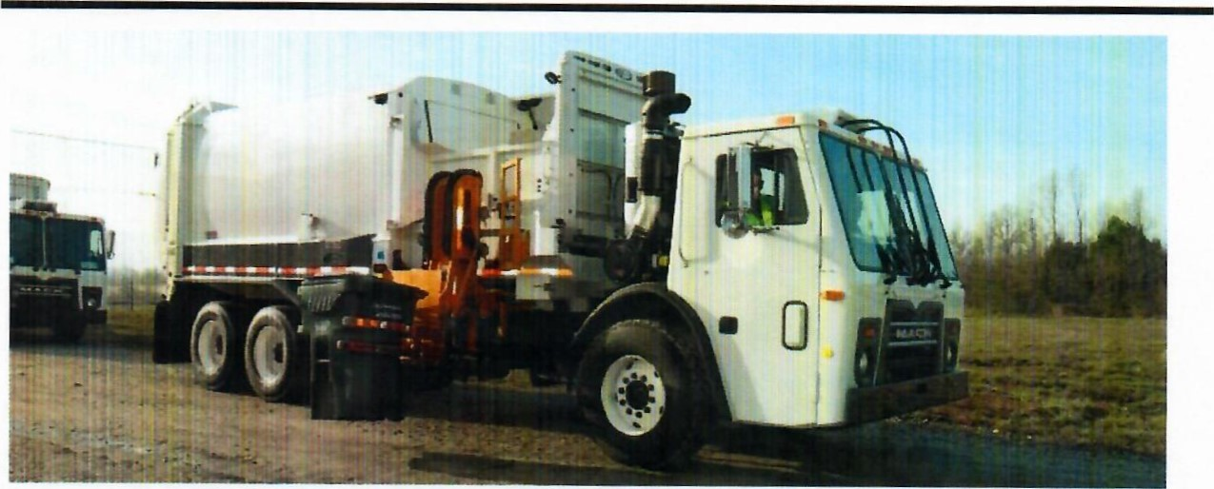
POLICIES AND | The City of Madisonville Public Works Department provides garbage
FEES | collection and disposal services for more than 11,000 residential and commercial customers. Each residential customer will be furnished one ½ cubic yard toter and charged a solid waste collection fee of $23.75 per month unless a separate commercial contract is in place for dumpster service at a multi-family complex or mobile home park.  All garbage must be contained in a city-issued toter. Additional toters are available for a fee of $5 per month per toter.  Customers shall position their toter curbside, with the lid closed and handle facing away from the street by 7 a.m. the day of collection and removed by 7 p.m. the day following collection.  For the safety of city employees, seasonal hours may be observed to avoid excessive temperatures. Garbage is collected once per week. To find out when your collection day is scheduled, please call (270) 824-2117.
DISCONTINUING SANITATION SERVICE
 | If a residential unit is vacant and unoccupied for a period over 60 consecutive days, the monthly solid waste collection fee can be suspended, provided the owner or the person having control of the unit notifies the City in writing. The owner or person having control of the residential unit shall immediately notify the City in writing when the unit is occupied. The collection fee for the unit shall be reinstated effective the first date of re-occupancy.

COMMERCIAL  DUMPSTER SERVICE  ROLL-OFF CONTAINERS | We offer services to the business community and large apartment complexes, through 2-8-yard commercial dumpsters and 96-gallon mobile carts. Depending upon the size of your business and your specific needs, we can help you pick the most cost-effective service.  For mobile cart collection, see the above Sanitation Policies and Fees.  For dumpster service:  All trash intended for pickup must be in the dumpster with the lids and side doors closed. Enclosures must conform to the Public Works Department size and construction requirements to reduce the risk of damage to property or personnel. Property owners must keep the enclosure and the area immediately around the dumpster clean and in good repair.  Ensure that service gates are kept in good repair and gate stops are installed and functional.  The path to the dumpster must be kept clear. We make reasonable attempts to collect your trash but we are not responsible for the approach being blocked. You could incur additional fees if it is blocked and we have to return to service the site repetitively. We will make a reasonable attempt to empty the dumpster's contents but we cannot be held responsible for items that are too lightweight to fall out on their own or items that span the interior width of the dumpster and become jammed.  If disposing of pallets, we ask that no more than two are discarded in any one load. As an alternate method of disposal, private entities exist that will collect pallets from your place of business.  We offer roll-off containers in the following sizes: 10, 20, 30, and 40-yd. call (270) 824-2117 for pricing.
LIMB & BRUSH  COLLECTION  BULKY & LARGE ITEM  COLLECTION  LEAF  COLLECTION  i-RECYCLE |  | All limb and brush collection are on the same day as the customer's regularly scheduled trash collection. If a customer's limbs or brush exceeds the size of a half-ton pickup, (8' long x 5' wide x 2' deep) there is a charge of $50 per load. Customers hiring tree trimmers should note that it is not the City's responsibility to remove any debris that the trimmers have created.  Large or bulky items are collected the same day as the customer's garbage collection day. Items such as refrigerators or air conditioners, which contain Freon, must be tagged by a certified company that all Freon has been removed. In addition, there will be a $35.00 charge for pick-up of items that have contained Freon. In regards to other large or bulky items, if the load exceeds that of a half-ton pickup, (8' long x 5' wide x 2' deep) there will be a charge of $50 per load.  Customers may also drop off bulky items during normal business hours at 900 McCoy Ave. There will be a minimum charge of $31.80 if the load weighs less than a ton or $60.00 per ton.  The City of Madisonville Public Works Department will begin its annual leaf pickup on Monday, November 15 (subject to change depending on how quickly the leaves begin to fall). Please have your leaves curbside for pickup on your regularly scheduled trash day. During this time there will be limited bulk item and limb pickup. We will make 4 passes through the city or run as long as weather permits.  iRecycle is Madisonville's convenient, single-stream, curbside recycling program available for FREE to our sanitation customers. All materials collected are sorted and processed at the City of Madisonville Recycling Center then shipped to processing mills.
Enrollment is easy! If you are currently a city of Madisonville sanitation customer, then you are eligible for the iRecycle program.
Simply visit http://www.gomadisonville.com/ and type in the search word "recycle". Click on the appropriate topic and enter your information into the system; email your name, address, and phone number to iRecycle@madisonvillegov.com; or give us a call at 270-824-2117.

